Subodh Public School

Session 2016-2017

Informatics practice

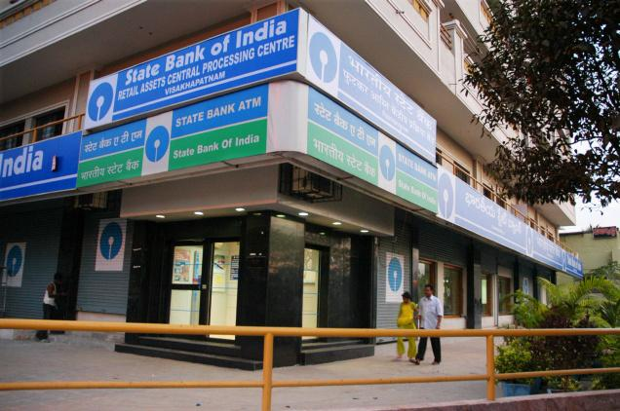

Made By : Radhika Saini

: Pallavi Sharma

Class : 12th E

Guided By : Mr.Praveen Bansal

Certificate

Acknowledgement

Forms

And

Coding

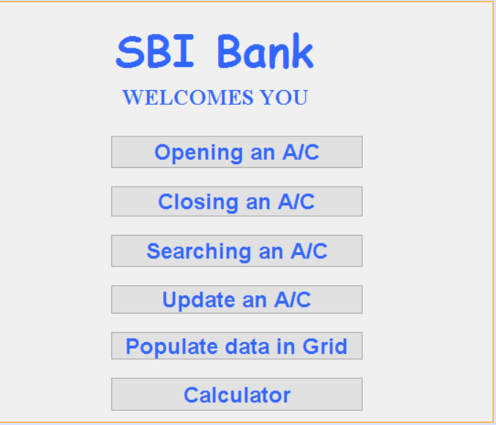

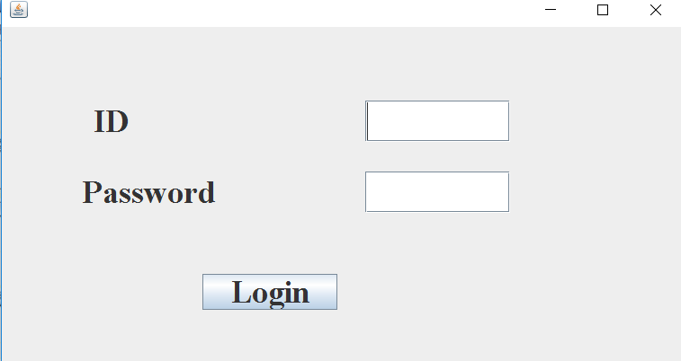

private void jButton1ActionPerformed(java.awt.event.ActionEvent evt) {

// TODO add your handling code here:

String id=jTextField1.getText();

String pwd=new String(jPasswordField1.getPassword());

if(id.equals("SUBODH")&&pwd.equals("SPS"))

{ homepage d= new homepage();

d.setVisible(true);

this.dispose();

}

else

JOptionPane.showMessageDialog(this,"Invalid User/Password");

}

/\*\*

\* @param args the command line arguments

\*/

public static void main(String args[]) {

java.awt.EventQueue.invokeLater(new Runnable() {

public void run() {

new login().setVisible(true);

}

});



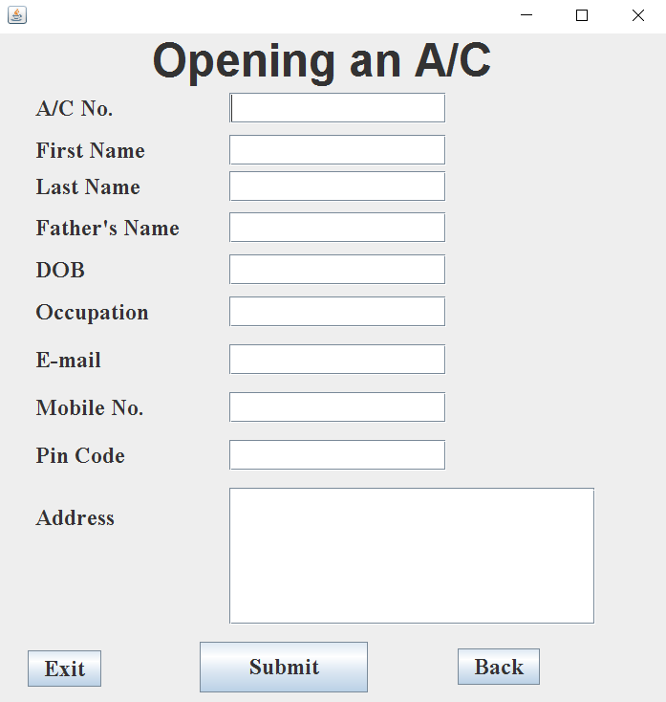

private void jButton1ActionPerformed(java.awt.event.ActionEvent evt) {

// TODO add your handling code here: try {Class.forName("java.sql.Driver");

Connection con =DriverManager.getConnection("jdbc:mysql://localhost:3306/sbi", "root","manager");

Statement stmt=con.createStatement();

String acc,fname,lname,fathern,dob,occupation,email,mobile,pin,address;

acc= jTextField1.getText();

fname= jTextField2.getText();

lname= jTextField3.getText();

fathern= jTextField4.getText();

dob= jTextField5.getText();

occupation= jTextField6.getText();

email= jTextField7.getText();

mobile= jTextField8.getText();

pin= jTextField9.getText();

address=jTextArea2.getText();

String sql= "insert into bank values('"+acc+"','"+fname+"','"+lname+"','"+fathern+"','"+dob+"','"+occupation+"','"+email+"',"+mobile+","+pin+",'"+address+"')";

stmt.executeUpdate(sql);

con.close();

}

catch (Exception e)

{JOptionPane.showMessageDialog(this, e.getMessage());

}

}

private void jButton2ActionPerformed(java.awt.event.ActionEvent evt) {

// TODO add your handling code here:

homepage h=new homepage();

h.setVisible(true);

this.dispose();

}

private void jButton3ActionPerformed(java.awt.event.ActionEvent evt) {

// TODO add your handling code here:

System.exit(0);

}

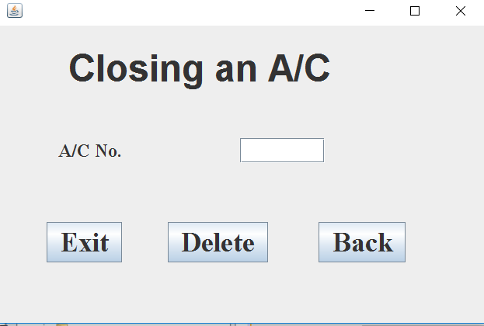



private void jButton1ActionPerformed(java.awt.event.ActionEvent evt) {

// TODO add your handling code here:

try {Class.forName("java.sql.Driver");

Connection con=DriverManager.getConnection("jdbc:mysql://localhost:3306/sbi", "root", "manager");

Statement stmt=con.createStatement();

String cls=jTextField1.getText();

String sql="delete from bank where acc="+cls;

stmt.executeUpdate(sql);

con.close();

} catch (Exception e)

{JOptionPane.showMessageDialog(this, e.getMessage());

}

}

private void

jButton2ActionPerformed(java.awt.event.ActionEvent evt) {

// TODO add your handling code here:

homepage h=new homepage();

h.setVisible(true);

this.dispose();

}

private void jButton3ActionPerformed(java.awt.event.ActionEvent evt) {

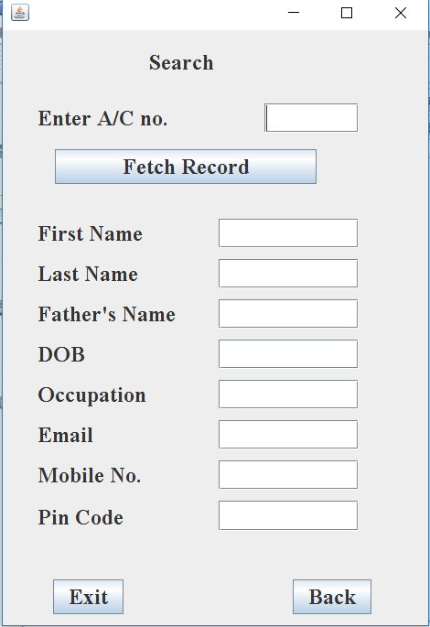

try {Class.forName("java.sql.Driver");

Connection con =DriverManager.getConnection("jdbc:mysql://localhost:3306/sbi", "root","manager");

String acc=jTextField1.getText();

String sql="select\*from bank where acc="+acc;

Statement stmt=con.createStatement();

ResultSet rs=stmt.executeQuery(sql);

if(!rs.next())

JOptionPane.showMessageDialog(null,"NO such Record");

else{

jTextField2.setText(rs.getString("fname"));

jTextField3.setText(rs.getString("lname"));

jTextField4.setText(rs.getString("fathern"));

jTextField5.setText(rs.getString("dob"));

jTextField6.setText(rs.getString("occupation"));

jTextField7.setText(rs.getString("email"));

jTextField8.setText(rs.getString("mobile"));

jTextField9.setText(rs.getString("pin"));

}

}

catch (Exception e)

{JOptionPane.showMessageDialog(null,"Error"+e.getMessage());

}

} private void jButton2ActionPerformed(java.awt.event.ActionEvent evt) {

// TODO add your handling code here:

homepage h=new homepage();

h.setVisible(true);

this.dispose();

}

private void jButton3ActionPerformed(java.awt.event.ActionEvent evt) {

// TODO add your handling code here:

System.exit(0);

}

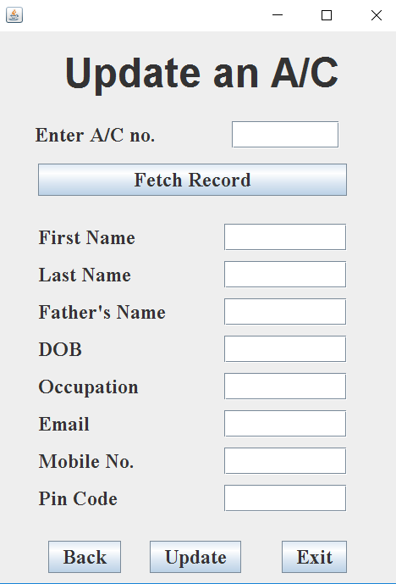

try {Class.forName("java.sql.Driver");

Connection con =DriverManager.getConnection("jdbc:mysql://localhost:3306/sbi", "root","manager");

String acc=jTextField1.getText();

String sql="select \* from bank where acc="+acc;

Statement stmt=con.createStatement();

ResultSet rs=stmt.executeQuery(sql);

if(!rs.next())

JOptionPane.showMessageDialog(null,"NO such Record");

else{

jTextField2.setText(rs.getString("fname"));

jTextField3.setText(rs.getString("lname"));

jTextField4.setText(rs.getString("fathern"));

jTextField5.setText(rs.getString("dob"));

jTextField6.setText(rs.getString("occupation"));

jTextField7.setText(rs.getString("email"));

jTextField8.setText(rs.getString("mobile"));

jTextField9.setText(rs.getString("pin"));

}

}

catch (Exception e)

{JOptionPane.showMessageDialog(null,"Error"+e.getMessage());

}

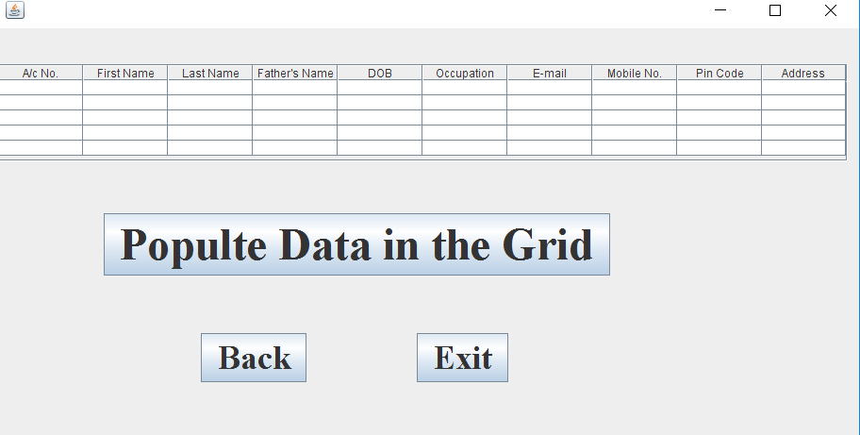

try {Class.forName("java.sql.Driver");

Connection con= DriverManager.getConnection("jdbc:mysql://localhost:3306/sbi", "root", "manager");

String acc,fname,lname,fathern,dob,occupation,email,mobile,pin,address;

String sql="select\* from bank";

Statement st=con.createStatement();

ResultSet rs=st.executeQuery(sql);

DefaultTableModel model=(DefaultTableModel)jTable1.getModel();

int rows=model.getRowCount();

if(rows>0)

{

for(int i=0; i<rows; i++){

model.removeRow(0);

}

}

while(rs.next()){

acc= rs.getString("acc");

fname= rs.getString("fname");

lname= rs.getString("lname");

fathern= rs.getString("fathern");

dob= rs.getString("dob");

occupation= rs.getString("occupation");

email= rs.getString("email");

mobile= rs.getString("mobile");

pin= rs.getString("pin");

address= rs.getString("address");

model.addRow(new Object[]{acc,fname,lname,fathern,dob,occupation,email,mobile,pin,address});

}

}

catch (Exception e) {

System.out.println("error"+e.getMessage());

}

}

private void jButton2ActionPerformed(java.awt.event.ActionEvent evt) {

// TODO add your handling code here:

homepage h=new homepage();

h.setVisible(true);

this.dispose();

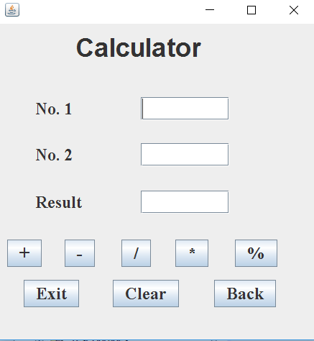

int n1=Integer.parseInt(jTextField1.getText());

int n2=Integer.parseInt(jTextField2.getText());

int result= n1+n2;

jTextField3.setText(result+"");

}

private void jButton2ActionPerformed(java.awt.event.ActionEvent evt) {

// TODO add your handling code here:

int n1=Integer.parseInt(jTextField1.getText());

int n2=Integer.parseInt(jTextField2.getText());

int result= n1-n2;

jTextField3.setText(result+"");

// TODO add your handling code here:

int n1=Integer.parseInt(jTextField1.getText());

int n2=Integer.parseInt(jTextField2.getText());

int result= n1\*n2;

jTextField3.setText(result+"")

} private void jButton5ActionPerformed(java.awt.event.ActionEvent evt) {

// TODO add your handling code here:

int n1=Integer.parseInt(jTextField1.getText());

int n2=Integer.parseInt(jTextField2.getText());

int result= n1%n2;

jTextField3.setText(result+"");

}

private void jButton6ActionPerformed(java.awt.event.ActionEvent evt) {

// TODO add your handling code here:

jTextField1.setText("");

jTextField2.setText("");

jTextField3.setText("");

}

private void jButton7ActionPerformed(java.awt.event.ActionEvent evt) {

// TODO add your handling code here:

homepage h=new homepage();

h.setVisible(true);

this.dispose();

}

private void jButton8ActionPerformed(java.awt.event.ActionEvent evt) {

// TODO add your handling code here:

System.exit(0);